Type-C 4-Port Integral USB3 Hub
Enabling a powerful 4-Port USB3 Hub for all your USB connected peripherals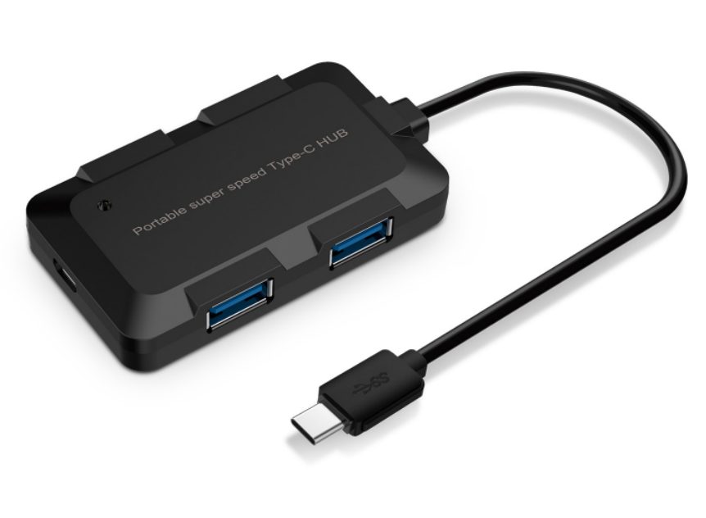

Descrption:
Combine the power of USB-C technology on your MacBook(tm),
Windows(tm) or other digital device with an integral 4-port USB3 Hub. Ideal
for simultaneous connection of almost any USB device including keyboards,
mice, USB storage at the same time.
With the added advantage of a PD charge port, the hub is ideal for
notebooks and other computers that do not have a regular USB port on
board.

Features:
- Connected to computer directly, Plug and Play, support hot plug
- LED Light Indicates When Powers On
- USB Ports, Power Supply of each USB Port could be 500mA Max
- Built-in current overload short-circuit protection
- Support 4PCS USB Devices Max
- Supporting System: Win95/98/Me/2000/XP/Win7/Win8/Win10,Linux2.4 and macOS8.5

Plug and Play, No Driver Installation Required

Specifications
- Material: ABS Plastic
- Cable Length: 70cm
- Color: black
- Transfer Port : USB 3.0
- Input Voltage : 5V
- Certificate: CE FCC ROHS
- Operating Temperature:0℃ to +45℃
- Operating Humidity:10%0 to 85 % RH
- Storage Temperature : -10℃ to +55℃
- Storage Humidity: 5% to 90 % RH

Product Code:
Part number: C-TC-USB3HUB
Barcode: 8400800036575
Size: 72.5mm x 41.2mm x 11.4mm
Weight: 45g

